Thermo-optical effect in a Mach-Zehnder interferometer on a silicon nitride platform for BIOphotonic applications
^{1,2} A. Yu. Kuzin ✉, ^{2,3} A. N. Lyubchak, ^{2,3} V. S. Andreev, ² A. D. Golikov,
^{2,4,5} P. P. An, ^{2,4,5} V. V. Kovalyuk, ^{2,3} G. N. Goltsman

¹Skolkovo Institute of Science and Technology, Moscow, Russia
²Department of Physics, Moscow State Pedagogical University, Moscow, Russia
³National Research University Higher School of Economics, Moscow, Russia
⁴NTI Center for Quantum Communications, National University of Science and Technology MISiS, Moscow, Russia
⁵Russian Quantum Center, Skolkovo, Moscow, Russia
✉ Aleksei.Kuzin@skoltech.ru

Abstract. Here we study the experimental dependence of the Mach-Zehnder interferometer transmission spectrum on the thermo-optical effect for cases of a microheater and a 3D stage with temperature control. Numerical 2D waveguide cross section model was developed for studying on-chip microheater performance. The results of this work can be used to create precision phase modulators to create compact sensitive biosensors for clinical applications, ecology monitoring, microwave and quantum photonic applications.
Funding: We acknowledge support of the Russian Science Foundation, grant No. 21-72-10117.

Introduction

The Mach-Zehnder interferometer (MZI) with a phase shifter is a wide spread technique for building receivers for signal-to-noise operation [1]. It is related with necessary to achieve phase stabilization and low optical losses. Due to low optical losses in C-Band and CMOS-compatible route [2], the technology of creating photonic integrated circuits on a silicon nitride (${Si}_{3}N_{4}$) platform becomes promising. However, the contribution of both internal (microheaters) and external (hot plate) temperature sources on the phase shift for one device based on ${Si}_{3}N_{4}$ platform still not studied.
In recent work a graphene microheater design on top of a silicon nitride waveguide with lower power and low switching temperature was reported [3]. However, the optical losses (~12 dB) in the interferometer arm due to graphene absorption on waveguide were significant. Also, the study for thermo-optical effect due to a side located gold microheater on the waveguide structure based on silicone on isolator (SOI) platform was demonstrated [4]. However, the absence of an interferometric or resonance waveguide structure does not allow to analyze the spectrum shifting depending on the thermo-optical effect directly. There was a voltage of 3.5 V applied to the microheater in the framework study thermo-optical effect on ${Si}_{3}N_{4}$ platform [2], which lead to the change in the central wavelength position for the MZI spectrum equal to 3.8 nm. But due to the microheater location atop of the waveguide through the thermal rough oxide layer (SiO₂), it was not possible to increase the voltage on the microheater by more than 7 V, which limited the possibility of thermo-optical tuning.
In all of these examples, metal or semiconductor microheaters were suitably integrated near to or above the waveguide layer and were operated as thermo-optic phase shifters. However, the shift in the spectral characteristics of the MZI for these device implementations was limited by the operation of microheaters. The thermo-optic phase shift is directly proportional to the temperature increase in the waveguide and its effective optical length [4]. Therefore, for an additional shift in the spectral characteristic the combination of on-chip microheaters with external sources of temperature adjustment is possible to use both together and separately. In this paper, we experimental and numerical study the efficiency of using microheaters on a chip with respect to external temperature sources for potential including in real biophotonics sensors.

Materials and Methods

For device fabrication and simulation commercially available substrates were used. There are 450 nm thickness ${Si}_{3}N_{4}$ film as a waveguide layer, SiO₂ buffer layer equals 2.6 µm, and silicon substrate (Si) is equal to 525 µm.
Fabrication process of nanophotonic structure (Fig.1(a,b)) includes following steps: chip cleaning and cutting; e-beam lithography with resist development (O-Xylene) and reflow; reactive-ion etching in CHF₃ atmosphere; alignment marks and contact pads definition via photolithography, Ti/Au deposition and lift-off process; finishing cleaning of the chip.
The wave optics and solid heat transfer modules in COMSOL Multiphysics were used to determine the electric field distribution (Fig.2(b)) and the dependence of the temperature in the waveguide on the voltage value applied to the microheater (Fig.2(c)). The thermo-optic coefficients for the silicon nitride/oxide layers, as well as for the gold layer, were taken from published works [5] and [6], respectively.
To measure the dependence of the thermo-optical effect for MZI on microheaters on a chip and an external temperature source the experimental setup shown in Figure 1 (c) was used. The light from tunable laser (1510 – 1620 nm) was inputted/outputted to the chip by using focusing grating couplers (FGCs) [7] and through the preliminary aligned fiber array was measured by fast photodetector. Polarization controller was used for maximization output power at the photodetector. A fixed voltage value was applied to the microheater and the current was measured. Additionaly, the phase shift was also controlled by changing the 3D stage temperature.
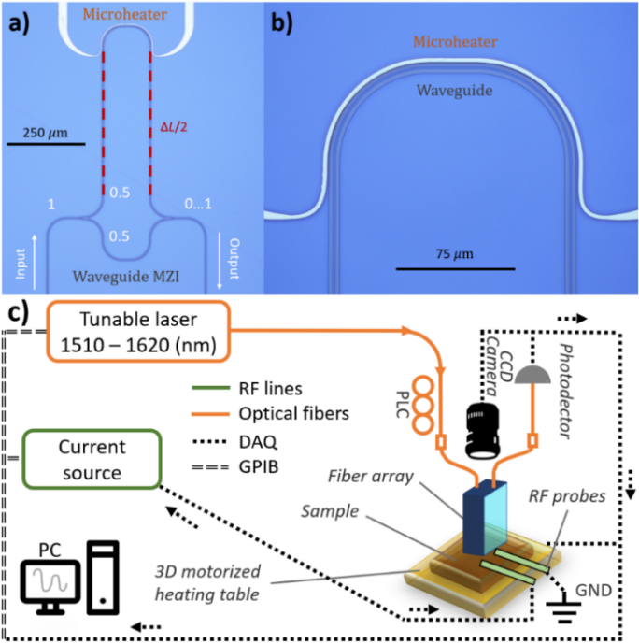
Fig 1. a, b) Microphotos of the MZI with microheater; c) schematical image of experimental setup.
Results and Discussion

Firstly, a 2D model of the waveguide cross section was developed to determine the optimal geometric parameters in the case of propagation the fundamental TE mode at a wavelength of 1550 nm (Fig. 2(a)). The dispersion of the real part of the refractive index for all materials was taken from an open web source [8]. After that the modeling of heat propagation from the microheater was carried out for the topology, and geometry of the waveguide was provided (Fig. 10(a)). The dependence of temperature at the waveguide center on the applied voltage to the microheater was used in the device developing and group refractive index calculation (Fig. 2(d)).
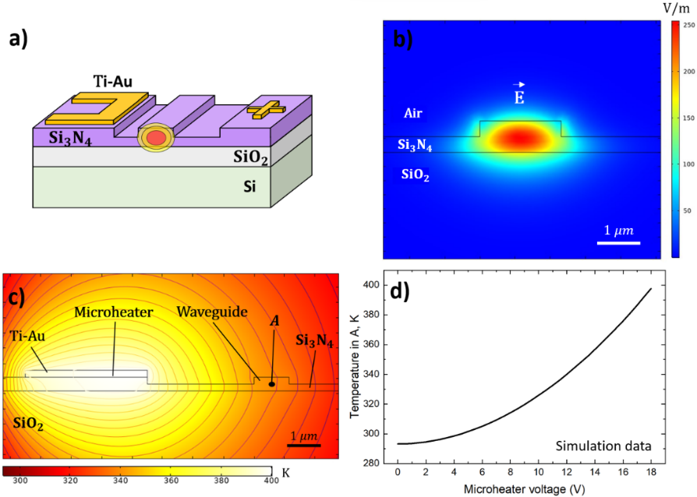
Fig. 2. а) Chip design topology (not in the scale); b) Distribution of the normalized electric field in the cross-section model of a semi-etched waveguide; с) Temperature distribution from a microheater in a semi-etched waveguide configuration; d) Dependence of the temperature in the center of the waveguide (A) on applied voltage to on microheater.
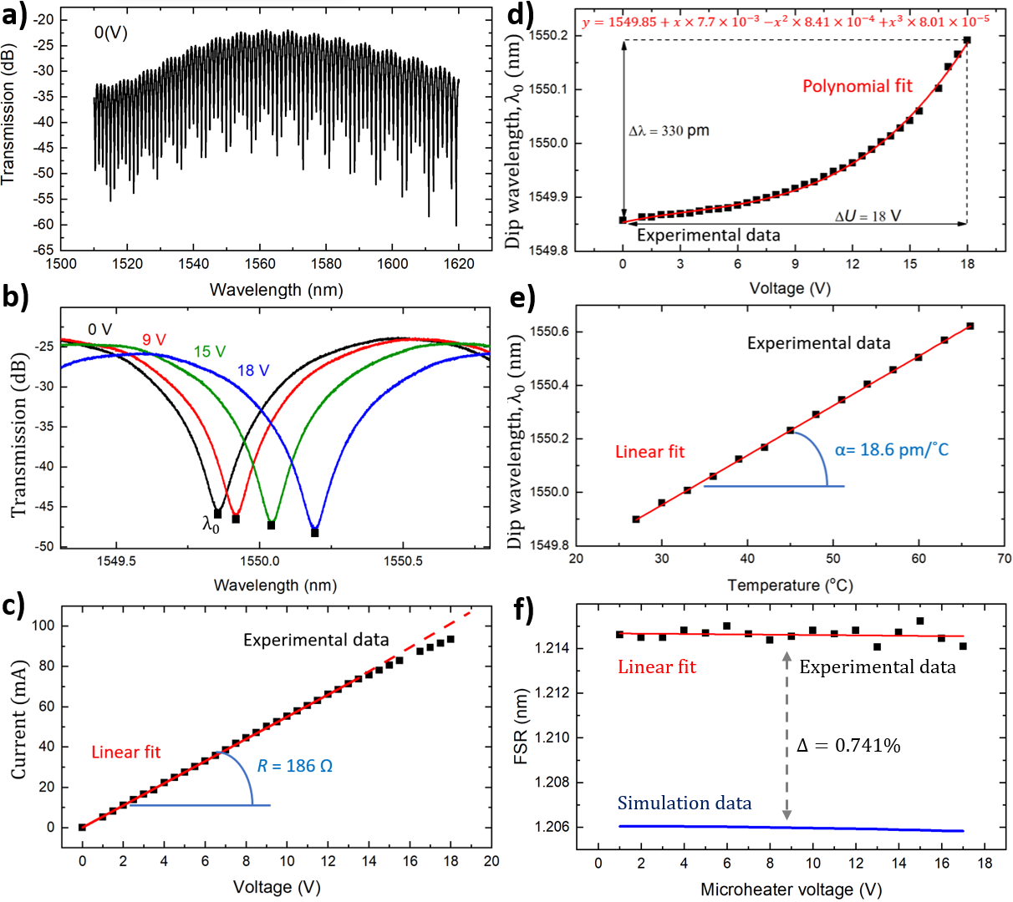

Fig. 3. а) Experimental MZI spectrum in range from 1510–1620 nm; b) Zoomed section of the transmission spectrum close to 1550 nm at different voltage values; c) IV-curve of the microheater; d) The dependence of dip wavelength on the microheater voltage; e) Dependence of dip wavelength on 3D stage temperature; f) FSR dependence on applied microheater voltage for experimental and simulation data.
Secondly, MZI based on ${Si}_{3}N_{4}$ platform with microheater from Ti/Au was fabricated. Figure 1(a,b) shows microphotographs of the fabricated MZI structure on a ${Si}_{3}N_{4}$ platform with Ti/Au phase modulators. The geometric difference between the length of the arms (ΔL) for the MZI was equal to 952 μm to provide a free spectrum range of approximately 1 nm. The microheater with 4 μm width 230 nm thickness was located at 4.5 μm from the waveguide.
Thirdly, the fabricated device was tested by using experimental setup. Tuning voltages were applied to the microheater, and the dip wavelength (Fig.3 (b)) in MZI spectrum (Fig.3(a)) measured. Voltage values ​​were changed from 0 V to 18 V with 0.5 V steps, every 2 minutes (Fig.3(c)). Under the influence of Joule heating, the effective refractive index changed, which affected on the optical path and further on the phase difference in the MZI arms (Fig.3(b)). The experimental results by using a microheater are demonstrated in Fig.3(d). The maximum change in dip wavelength ($λ_{0}$) with increasing voltage from 0 to 18 V was measured as 0.33 nm.
Additionally, the phase shift was controlled by changing the 3D stage temperature. Figure 3 (e) shows the linear dependence of the $λ_{0}$on the stage temperature. The slope of the straight line was found as 18.57±0.11 pm/°С. Thus, in instance to shift $λ_{0}$by 0.33 nm, it is necessary to increase the temperature of the entire structure by 18°C or apply a voltage of 18 V to the microheater.
At the final stage, the results of the numerical 2D model were compared with the experimental data on the FSR (Free Spectral Range). The experimental FSR was defined as the distance between neighboring $λ_{0}$ near 1550 nm. FSR simulation was carried out through group refractive index calculation by using algorithm which was presented in supplementary materials for the work [9]. The relative deviation between the experimental and simulation data was 0.741% (Fig.3 (f)). This relative deviation is caused by the inaccuracy of the input model parameters (thermo-optic coefficients), which were taken from literary data [5,6].
Conclusion

In this work, both numerical simulation and experimental study of a side located gold microheater from waveguide for a Mach-Zehnder interferometer on a chip were carried out. The results obtained make it possible to evaluate the thermo-optical effect due to microheaters on a chip relative to external sources of temperature adjustment. Thus, to shift the MZI spectrum by 330 pm, it is necessary to increase the external source temperature by 18°C or apply a voltage of 18 V to the microheater. These data are promising for creation precision phase modulators to create compact sensitive biosensors for clinical applications, ecology monitoring, microwave and quantum photonic applications.
REFERENCES

1. Sych D., Leuchs, G., Practical receiver for optimal discrimination of binary coherent signals. Physical review letters, 117(20) (2016), 200501.
2. Venediktov I. O., Elezov M. S., Prokhodtsov A. I., Kovalyuk V. V., An P. P., Golikov A. D., Shcherbatenko M. L., Sych D. V., Goltsman G. N., Study of microheater’s phase modulation for on-chip Kennedy receiver. In Journal of Physics: Conference Series (Vol. 1695, No. 1, p. 012117) (2020) IOP Publishing.
3. Qiu C., Zhang C., Zeng H., Guo T., High-Performance Graphene-on-Silicon Nitride All-Optical Switch Based on a Mach–Zehnder Interferometer. Journal of Lightwave Technology, 39(7) (2021) 2099-2105.
4. Kaushal S., Das B. K., Modeling and experimental investigation of an integrated optical microheater in silicon-on-insulator. Applied Optics, 55(11) (2016), 2837-2842.
5. Komrakova S., An, P. Kovalyuk, V. Golikov, A. Gladush, Y. Mkrtchan A., Nasibulin A., Goltsman G., Thermo-optical properties of nanophotonic devices with carbon nanotube films. In Journal of Physics: Conference Series (Vol. 2086, No. 1, p. 012149) (2021) IOP Publishing.
6. Aleali H., Sarkhosh L., Eslamifar M., Karimzadeh R., Mansour N., Thermo-optical properties of colloids enhanced by gold nanoparticles. Japanese Journal of Applied Physics, 49(8R) (2010) 085002.
7. Kuzin A., Kovalyuk V., Golikov A., Prokhodtsov A., Marakhin A., Ferrari S., Pernice W., Gippius N., Goltsman G., Efficiency of focusing grating couplers versus taper length and angle. In Journal of Physics: Conference Series (Vol. 1410, No. 1, p. 012181) (2019) IOP Publishing.
8. RefractiveIndex.INFO. URL: https://refractiveindex.info/. Accessed May 30, 2022.
9. Kuzin A., Chernyshev V., Kovalyuk V., An P., Golikov A., Ozhegov R., Gorin D., Gippius N., Goltsman, G., Hybrid nanophotonic–microfluidic sensor for highly sensitive liquid and gas analyses. Optics Letters, 47(9) (2022) 2358-2361.

