MATHEMATICAL MODELING OF VIBRATION SPECTRA OF OPTICALLY ACTIVE AMINO ACIDS FOR THE PURPOSES OF ANTI-PLATELET THERAPY
Recently, optical methods have become one of the main tools for biomedical applications and have made significant progress in the field of clinical evaluation [1]. A number of natural tissues were studied using spectroscopic methods, including Raman spectroscopy [2, 3]. These vibrational spectroscopy methods are relatively simple, reproducible, do not destroy tissue, and require only small amounts of material (from micrograms to nanograms) with minimal sample preparation. In addition, these methods provide information at the molecular level, allowing the study of functional groups, bond types, and molecular conformations. Spectral bands in vibrational spectra depend on the molecule and provide direct information about the biochemical composition. These bands are relatively narrow, easily resolvable, and sensitive to molecular structure, conformation, and environment. A necessary part of the practical study of any sample is the theoretical prediction of the result in order to better understand the structure of the analyte. This part of the analysis is necessary for a more accurate selection of shooting parameters and a visual representation of the expected result. One of such prediction methods is mathematical modeling. The present work reflects the results of studies of SERS spectroscopy of human platelets and their comparison with theoretical Raman spectra of organic compounds, which were chosen as amino acids (phenylalanine, tyrosine, tryptophan, cysteine), lipophilic alcohol (cholesterol) and lipids (phosphatidylethanolamine). Mathematical modeling was carried out using the GAUSSIAN 16 and TURBOMOLE programs by the DFT method using the B3LYP and BP86 functionals, respectively. To study the spectra of surface enhanced Raman spectroscopy (SERS) scattering, we used a Centaur U HR Raman spectrometer (OOO «Наноскантехнология», Russia and ZAO SolarLS, Republic of Belarus), on which, using a Cobolt Samba DPSS laser (532 nm) with a power of 50 mW, the spectra of SERS radiation were obtained. light scattering of platelets adsorbed on a layer of gold hydrosols thermally deposited on a rough titanium substrate.
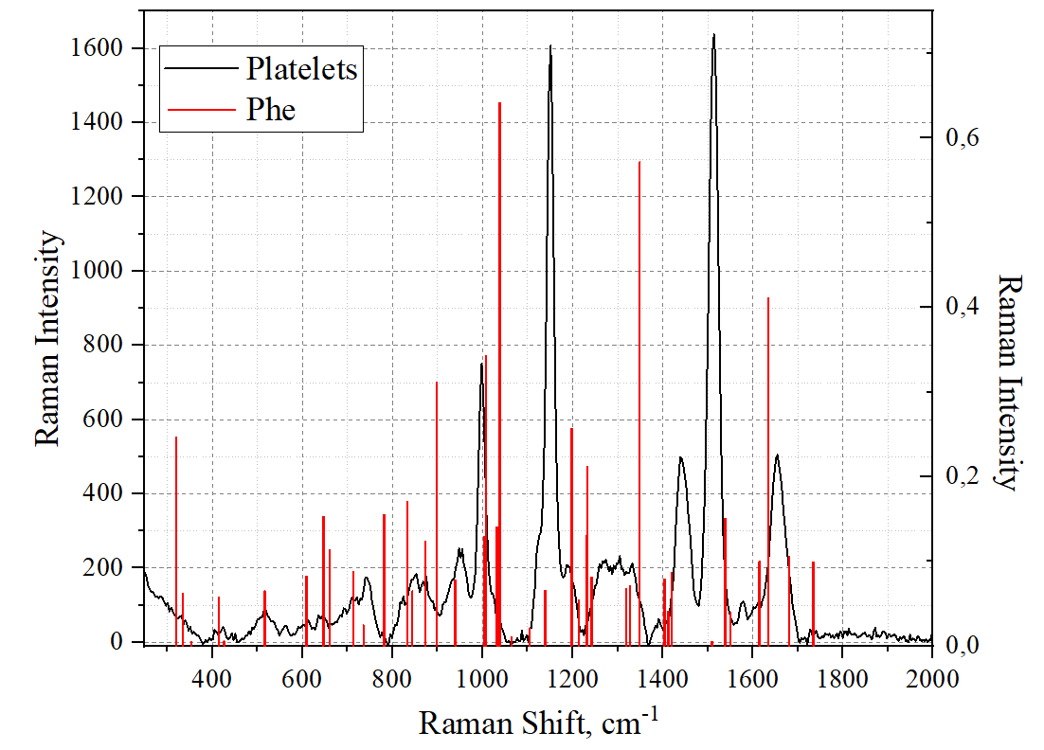

Fig. 1. SERS spectrum of human platelets and simulated vibrational modes of phenylalanine.

CONCLUSION
The paper shows the promise of using the proposed approach as an effective method for studying a wide range of compounds using SERS.
LITERATURE
- Katie Hanna et al. Raman spectroscopy: current applications in breast cancer diagnosis, challenges and future prospects, National Library of Medicine, 2021;
- Ola Ibrahim et al. The Potential of Raman Spectroscopy in the Diagnosis of Dysplastic and Malignant Oral Lesions, Open Access Journals, Special Issue "Biophotonics and Imaging for Cancer Screening, Diagnosis and Treatment Monitoring", 2021;
- Santosh Kumar Paidi et al. Raman Spectroscopy and Machine Learning Reveals Early Tumor Microenvironmental Changes Induced by Immunotherapy, Cancer Research, 2021;

The study was supported by the Ministry of Science and Higher Education of the Russian Federation, Project number 075-02-2022-872.

