Determination of methotrexate in micromolar concentrations using glasses with a modified nanostars surface.
Evtifeev D.O.ª, Zozulya A.S.ª, Demishkevich E.A. ^{a b}, Kundalevich А.А ^{a b}, Zyubin А.Y. ª Samusev I.G. ª

- Immanuel Kant Baltic Federal University, Kaliningrad, Russia
- Saratov National Research State University named after N.G. Chernyshevskogo, Saratov, Russia
E-mail: d.o.evtifeev@mail.ru

Methotrexate is a drug used in the treatment of rheumatoid arthritis. At high concentrations in human blood, it has a toxic effect on its body, so the qualitative and quantitative determination ofthe oncentration of methotrexate in the human body is animportant task [1,2]
As part of this study, the results of Raman scattering of methotrexate light using gold nanostars on APTES-modified glasses were obtained, for which the Virsa (Renishaw) speck trometer with an excitation wavelength (λ = 785 nm) was used.
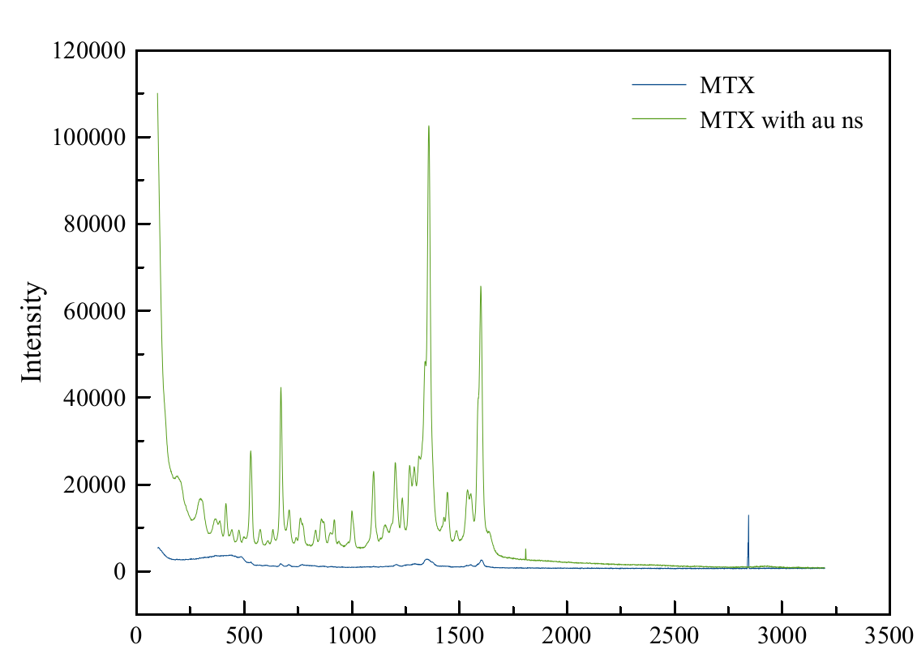
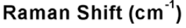
Fig.1. Experimental methotrexate spectrum using gold nanostars on APTES-modified glasses (green) and without their use (blue).
Conclusion. As can be seen from the data presented, the spectra of methotrexate obtained on APTES-modified glasses have a high intensity, which indicates the presence of amplification of the cattle signal, which, in turn, makes it possible to detect lower concentrations of methotrexate, up to micromolar, which are contained in human blood.
Taking into account the above facts, it can be concluded that this technology can be not only more effective, but also much cheaper and easier to perform.
LITERATURE
- Göksel Y. et al. Quantification of Methotrexate in Human Serum Using Surface-Enhanced Raman Scattering—Toward Therapeutic Drug Monitoring //ACS sensors. – 2021. – Т. 6. – №. 7. – С. 2664-2673.
- Van der Veen M. J. et al. Infection rate and use of antibiotics in patients with rheumatoid arthritis treated with methotrexate //Annals of the rheumatic diseases. – 1994. – Т. 53. – №. 4. – С. 224-228.

