Plasmon-enhanced fluorescence spectroscopy of aromatic amino acids using rhodium nanoparticles

Plasmonics is a modern direction of photonics, which requires the study of electrons vibration in metal nanostructures and nanoparticles, as well as the interaction of these vibrations with atoms and molecules, in order to create optical nanodevices.
Noble metals such as gold, silver and copper are used to synthesize nanoparticles, but they are suitable for studying only in the visible and near infrared ranges. The development of science and the need to work with a variety of biological compounds that have fluorescence spectra in the ultraviolet region indicate the importance of studying the UV - range. Currently, theoretical studies have already been carried out that prove that Rh has a strong UV plasmon response.
In this paper, rhodium nanoparticles (NPs) were synthesized and photoprocesses in complexes of an aromatic amino acid and rhodium nanoparticles were studied. Two aromatic amino acids were chosen for the study: tyrosine and tryptophan, which are part of the human platelet membrane. In the course of the work, the dependences of the fluorescence intensity of tryptophan and tyrosine on the concentration of rhodium nanoparticles in solution were determined. The prospects of rhodium nanoparticles for the purposes of plasmonics in the ultraviolet region are demonstrated.
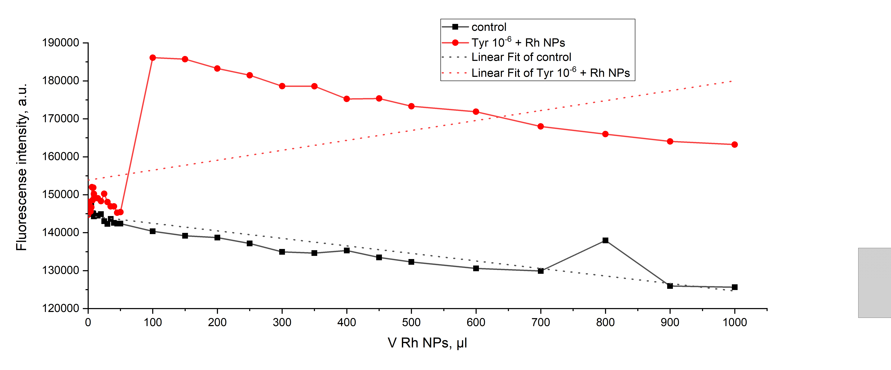
Figure 1. Dependence of the maximum fluorescence intensity of tyrosine 10-6 M on the added volume of rhodium NPs.

The study was supported by the Ministry of Science and Higher Education of the Russian Federation, Project number 075-02-2022-872

Abstract
The paper presents studies of aromatic amino acids Tyr and Tpr with the participation of rhodium nanoparticles. The practical application of this work is the use of the results obtained to create the fundamentals of an optical sensor for diagnosing platelet changes.

