Type Title of Document Here [Main Title style]
[Main Title Style]: Times new Roman, Font size 14, Bold, centred

Petr Firstauthor¹, Ivan Secondauthor² and Elena Thirdauthor³
[Authors list]: Times new Roman, font size 10, centred. Presenting author underlined, co-authors separated by commas and last author by “and” without comma. All authors full first names. No initials and no middle names.

¹Department, Organisation, Country
²Department, Organisation, Country
[Institutions list]: Times new Roman, font size 9, italics, centred.
No postal addresses, no ZIP codes, no cities

petr.firstauthor@university.org
Email address of presenting author only (Times new Roman, font size 9, centred).
Ensure it is not formatted as email hyperlink (i.e. blue and underlined).

Abstract [Heading 1 style]
[Heading 1 style]: Times new Roman, in capital letters, font size 10, bold.
Document abstract goes here. It should include a concise description of the results and findings of the research. The abstract should be 4 - 6 full pages. It must be written in English, in times New Roman, 10, single space.
The abstract can include formulas and figures (colored figures are preferable), reference should appear in parentheses (Fig. 1). Bibliographical references should be referenced in the text into square brackets [1,2], Vancouver style.

[Body Text style]: Times New Roman, font size 10, text justified

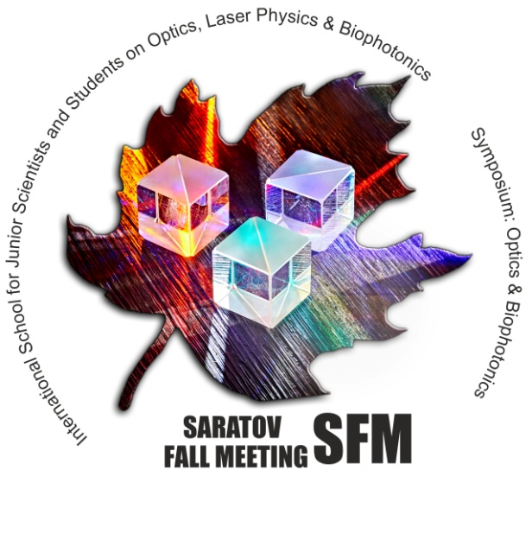
(a)

Figure: (a) Conference logo.
[Figure style]: Times new Roman, font size 9, italics, text centered

REFERENCES [HEADING 1 STYLE]
Example:
- V.V. Tuchin, Tissue Optics: Light Scattering Methods and Instruments for Medical Diagnostics, 3rd ed., SPIE Press, Bellingham, Washington , p. 988, 2015.
- Z. Zhi, Z., Han, Q. Luo, D. Zhu, Improve optical clearing skin in vitro with propylene glycol as a penetration enhancer , J. Innovat. Opt. Health Sci. 269–278, 2009.

[Reference style]: Times new Roman, font size 9, text justified

